Name: Unnathi Vithlani
Course: CS-7346
Date: July 29, 2025

Where's Fluffy?
Enhanced Cloud-Based Pet Recovery Platform
Where's Fluffy is a cutting-edge platform designed to revolutionize pet recovery through advanced technology and community engagement. This presentation outlines the technical architecture, key features, and strategic vision behind our solution



Executive Summary
The "Where's Fluffy?" platform addresses the critical gap in pet recovery services by providing a centralized, cloud-based solution that transforms individual search efforts into coordinated community initiatives. Unlike fragmented methods such as Craigslist posts and neighborhood fliers, our platform offers real-time GPS tracking, mandatory photo verification, and integrated reward management.
Built on AWS microservices architecture, the system prioritizes 99.9% availability, sub-200ms response times, and end-to-end security while maintaining mobile-first accessibility. Key differentiators include escrow-based reward transactions, community-driven sighting reports, and location-aware pet discovery within configurable radius zones.
The scalable design supports growth from single-city implementations to multi-metropolitan coverage, with a phased rollout strategy targeting 70% pet recovery rates and sustainable platform economics through transaction fees.
Problem Analysis
Current Pet Recovery Challenges
Fragmented Communication Channels Traditional pet recovery relies on scattered platforms like Craigslist, Facebook groups, and physical fliers, resulting in delayed information sharing and missed opportunities for quick reunions. Pet owners often struggle to reach the right audience at the right time.
Lack of Location Intelligence Current methods provide no GPS-enabled tracking or location-based search capabilities. This fundamental limitation prevents efficient coordination of search efforts and reduces the likelihood of successful recoveries in time-sensitive situations.
Trust and Verification Issues Without standardized verification processes, pet owners face challenges distinguishing legitimate finder reports from fraudulent claims. The absence of photo proof requirements and secure reward management creates additional barriers to successful pet recovery.
Limited Community Engagement Existing platforms lack collaborative features that enable coordinated community search efforts, reducing the overall effectiveness of recovery operations and missing opportunities to leverage local knowledge and resources.

Requirements Analysis
Functional Requirements
Core Platform Functions:
- User Registration and Authentication: Secure account creation with email verification and location-based preferences
- GPS-Based Pet Discovery: Real-time viewing of missing pets within user-configurable radius (1-50 miles)
- Pet Listing Management: Comprehensive missing pet profiles with detailed descriptions, multiple photos, and status tracking
- Mandatory Photo Verification: Required photographic evidence for all "pet found" submissions with location and timestamp validation
- Reward Management System: Secure escrow service for reward offers, holding, and verified distribution
- Community Sighting Reports: GPS-tagged community submissions with photo evidence and confidence ratings
- Comment System: Location-aware commenting on pet listings with search coordination features
Advanced System Capabilities:
- Real-time Notifications: Push alerts for new sightings, found reports, and status updates
- Intelligent Search: Location-based queries with distance calculations and proximity matching
- Mobile Optimization: Native mobile applications with offline capabilities and camera integration
- Data Analytics: Search pattern analysis and recovery success metrics

Non-Functional Requirements
Performance Standards:
- API Response Time: <200ms for critical search and notification operations
- Image Processing: <5 seconds for photo upload and verification
- Concurrent Users: Support for 10,000+ simultaneous users per city
- Push Notifications: <30 seconds delivery time for urgent alerts
Scalability Requirements:
- Horizontal scaling capability for 10x traffic growth
- Multi-city expansion support with regional optimization
- Unlimited photo storage with global content delivery
- Linear performance scaling with user base growth
Security and Compliance:
- AES-256 encryption for data at rest, TLS 1.3 for data in transit
- OAuth 2.0 authentication with multi-factor options
- PCI DSS compliance for reward transactions
- GDPR compliance for data privacy and user rights
Assumptions
Several key assumptions underpin the design and implementation of the "Where's Fluffy?" platform:
Technology Infrastructure:
- Internet Connectivity: Pet owners and finders have reliable mobile internet access for real-time updates and photo uploads
- Smartphone Adoption: Target users possess smartphones with GPS capabilities and camera functionality
- Cloud Reliability: AWS services maintain advertised uptime and performance SLAs

User Behavior:
- Community Participation: Sufficient local community members willing to actively participate in pet recovery efforts
- Photo Compliance: Users will consistently provide mandatory photo proof for found pet submissions
- Location Sharing: Pet owners comfortable sharing approximate location data for their missing pets
- Reward Usage: Pet owners willing to offer financial rewards to incentivize recovery efforts
Business Environment:
- Legal Framework: No significant regulatory barriers to operating escrow payment services across target cities
- Market Demand: Sufficient pet ownership density in target metropolitan areas to justify platform investment
- Competition: Current solutions (Craigslist, social media) remain fragmented, creating market opportunity
Operational:
- User Education: Pet owners and finders can be effectively trained through intuitive UI/UX design
- Fraud Management: AI-powered photo verification combined with community moderation can effectively prevent fraudulent submissions
- Payment Processing: Stripe Connect API capabilities sufficient for escrow functionality and marketplace payments
- Geographic Expansion: Urban areas share similar pet recovery challenges, allowing replication of single-city success

Financial:
- Transaction Volume: Sufficient reward transactions to support platform sustainability through processing fees
- AWS Costs: Cloud infrastructure costs remain predictable and scalable with user growth
- Development Resources: Technical team capable of implementing and maintaining microservices architecture
Regulatory:
- Data Privacy: GDPR and regional privacy laws can be addressed through standard compliance frameworks
- Financial Services: Escrow operations fall within existing payment processor regulations
- Pet Recovery: No local ordinances prohibiting community-based pet recovery coordination
These assumptions should be validated through market research, pilot programs, and regulatory consultation during the implementation planning phase.
Relevant Stakeholders
Primary Stakeholders
1. Pet Owners Lost pet owners who create listings, manage reward offers, and confirm successful recoveries. They require immediate notification capabilities, comprehensive listing management, and secure reward transaction processing.
2. Pet Finders Individuals who discover lost pets and submit found reports with mandatory photo verification. They need easy reporting tools, reward collection capabilities, and communication channels with pet owners.
3. Community Members Local residents who participate in search efforts by submitting sighting reports, commenting on listings, and coordinating search activities. They require location-based listing access and collaborative communication tools.

4. System Administrators Technical staff responsible for platform maintenance, user support, dispute resolution, and system monitoring. They need comprehensive administrative tools and analytics dashboards.
Secondary Stakeholders
5. Local Businesses Pet-related businesses, veterinarians, and community sponsors who may advertise on the platform or provide services. They require business analytics and community engagement metrics.
6. Animal Welfare Organizations Shelters and rescue organizations that may coordinate with the platform for comprehensive pet recovery efforts. They need integration capabilities and bulk listing management tools.
Relevant Use Cases
1. Pet Owners
1.1. Create Missing Pet Listing Pet owners create detailed profiles including photos, descriptions, last seen location, and reward amounts. The system validates information completeness and activates GPS-based visibility.
1.2. Manage Reward Offers Owners set reward amounts held in secure escrow, modify reward values based on search duration, and authorize payments upon successful pet recovery confirmation.
1.3. Track Search Progress Owners monitor sighting reports, community comments, and search activity through real-time dashboards and receive push notifications for significant developments.
1.4. Verify and Confirm Recovery Owners review found pet reports with photo evidence, communicate with finders, and confirm successful recoveries to trigger reward distribution.
2. Pet Finders
2.1. Submit Found Pet Reports Finders locate missing pets and submit reports with mandatory photo proof, GPS location, and detailed observations through mobile-optimized interfaces.

2.2. Communicate with Pet Owners Finders coordinate with pet owners through secure messaging systems, arrange safe meeting locations, and provide additional verification as needed.
2.3. Collect Rewards Upon successful pet recovery confirmation, finders receive automatic reward payments through integrated payment processing systems.
3. Community Members
3.1. Browse Local Missing Pets Community members view location-based missing pet listings within configurable radius settings, filtered by pet type, time missing, and reward amounts.
3.2. Submit Sighting Reports Members report pet sightings with GPS-tagged locations, photos, and confidence levels, contributing to community-wide search coordination efforts.
3.3. Participate in Search Coordination Members comment on listings with search updates, coordinate with other volunteers, and mark areas as searched to prevent duplication of efforts.
4. System Administrators
4.1. Monitor System Performance Administrators track platform performance metrics, user engagement statistics, and system health indicators through comprehensive monitoring dashboards.
4.2. Resolve User Disputes Administrators mediate disputes between pet owners and finders, investigate fraudulent reports, and manage reward distribution conflicts.
4.3. Manage Platform Content Administrators moderate user-generated content, verify photo authenticity through AI analysis, and maintain platform integrity and user trust.
System Architecture
Microservices Architecture Overview
The system implements a cloud-native microservices architecture on AWS, enabling independent scaling, deployment, and maintenance of core functions. This approach ensures high availability, performance, and maintainability while supporting rapid feature development and geographic expansion.

Link for Architectural Diagram
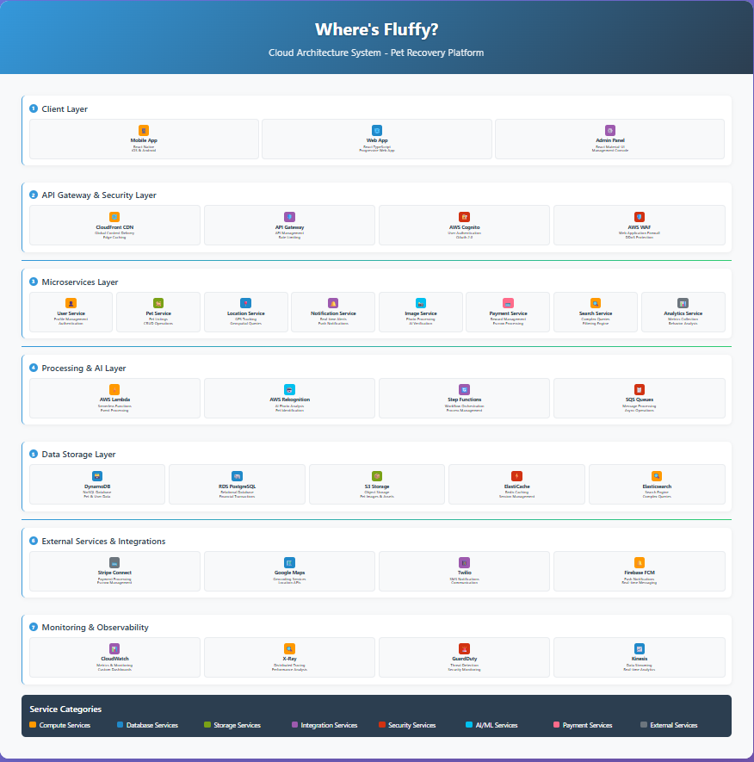
Core Microservices
1. User Service (ECS)
- Responsibilities: Registration, authentication, profile management, and location preferences
- Technology: Node.js with Express, AWS Cognito integration
- Data Store: DynamoDB for user profiles, Redis for session caching
- Scaling: Auto-scaling based on authentication requests

2. Pet Service (ECS)
- Responsibilities: CRUD operations for missing pets, status management, and listing analytics
- Technology: Node.js with Express, integrated image processing
- Data Store: DynamoDB with Global Secondary Index for location queries
- Scaling: Horizontal scaling with read replicas
3. Location Service (ECS)
- Responsibilities: GPS tracking, proximity searches, and geospatial analytics
- Technology: Node.js with geospatial libraries, Google Maps API
- Data Store: ElasticSearch for complex geospatial queries
- Scaling: Region-based sharding for global expansion
4. Notification Service (ECS)
- Responsibilities: Real-time push notifications, email alerts, and SMS integration
- Technology: Node.js with Socket.io, AWS SNS/SES integration
- Data Store: DynamoDB for notification logs and preferences
- Scaling: Event-driven architecture with SQS queues
5. Image Processing Service (Lambda)
- Responsibilities: Photo upload, AI verification, and storage management
- Technology: Python with OpenCV, AWS Rekognition
- Data Store: S3 for storage, DynamoDB for metadata
- Scaling: Serverless auto-scaling based on upload volume
6. Payment Service (ECS)
- Responsibilities: Escrow management, reward processing, and dispute resolution
- Technology: Node.js with Stripe Connect API
- Data Store: RDS PostgreSQL for financial transactions
- Scaling: Dedicated secure instances with enhanced monitoring

7. Search Service (ElasticSearch)
- Responsibilities: Advanced search capabilities and real-time indexing
- Technology: ElasticSearch with custom analyzers
- Data Store: ElasticSearch cluster with automated backups
- Scaling: Cluster scaling based on search volume
Data Structure Design
Core Data Models
The platform utilizes a hybrid database strategy combining NoSQL and SQL databases optimized for different use cases:
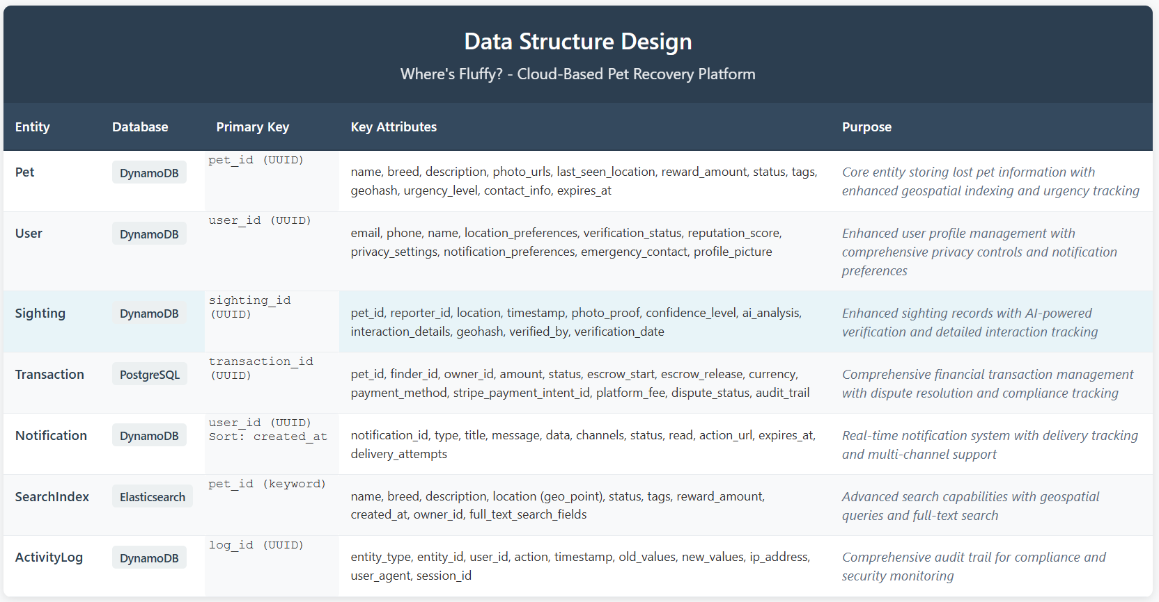
Database Strategy
DynamoDB (Primary NoSQL)
- Use Cases: User profiles, pet listings, sightings, notifications
- Advantages: Auto-scaling, high performance, global distribution
- Partitioning: Geographic regions for optimal data locality

PostgreSQL (Financial Transactions)
- Use Cases: Payment processing, audit trails, financial reporting
- Configuration: Multi-AZ deployment with automated backups
- Security: Enhanced encryption and access controls
ElasticSearch (Search and Analytics)
- Use Cases: Complex queries, geospatial search, full-text search
- Configuration: Multi-node cluster with automated scaling
- Features: Real-time indexing and advanced search capabilities
Software Quality Attributes
Priority-Ranked Quality Attributes
1. Security (Highest Priority) Critical for protecting user data, financial transactions, and maintaining platform trust. Implementation includes end-to-end encryption, secure authentication, and PCI DSS compliance for payment processing.
2. Availability (Highest Priority) Essential for emergency pet recovery scenarios requiring 24/7 platform access. Target: 99.9% uptime with automatic failover and disaster recovery procedures.
3. Performance (High Priority) Sub-200ms response times critical for mobile users in urgent situations. Includes optimized database queries, CDN implementation, and efficient image processing pipelines.
4. Scalability (High Priority) Platform must support rapid user growth and geographic expansion. Microservices architecture enables independent scaling of components based on demand patterns.
5. Usability (Medium Priority) Mobile-first design optimized for stress situations when users need quick, intuitive interfaces. Includes voice-to-text capabilities and one-touch reporting features.
6. Reliability (Medium Priority) Consistent system operation prevents lost opportunities for pet recovery. Includes comprehensive monitoring, automated testing, and graceful error handling.

7. Maintainability (Medium Priority) Supports rapid development and platform evolution. Microservices architecture and comprehensive documentation enable efficient updates and bug fixes.
8. Interoperability (Lower Priority) While important for future integrations with veterinary systems and animal shelters, not critical for initial platform success.
Trade-Offs
Critical Architectural Trade-Offs
Security vs. Usability Enhanced security measures including multi-factor authentication and photo verification may introduce friction in the user experience. However, given the platform's role in pet recovery and financial transactions, security takes precedence over convenience.
Performance vs. Consistency Implementing eventual consistency in DynamoDB improves performance but may result in temporary data inconsistencies. For pet recovery scenarios, slight delays in data synchronization are acceptable compared to system unavailability.
Scalability vs. Cost Auto-scaling microservices provide excellent scalability but increase operational complexity and costs. This trade-off is justified by the platform's need to handle sudden traffic spikes during pet emergencies.
Real-time Features vs. Battery Life GPS tracking and push notifications drain mobile device batteries. The platform implements intelligent location tracking that balances real-time accuracy with battery optimization.
Feature Richness vs. Simplicity Comprehensive features like AI photo analysis and advanced search capabilities add complexity. However, these features significantly improve success rates, justifying the additional complexity.
Cloud Services
AWS Service Selection and Justification
1. Amazon ECS (Container Orchestration)
- Advantages: Managed container orchestration, auto-scaling, integration with AWS services
- Limitations: Requires container management expertise, potential vendor lock-in

- Justification: Enables microservices deployment with minimal infrastructure management
2. AWS Lambda (Serverless Computing)
- Advantages: Auto-scaling, pay-per-execution, no server management
- Limitations: Cold start latency, execution time limits
- Justification: Perfect for image processing tasks with variable workloads
3. Amazon DynamoDB (NoSQL Database)
- Advantages: Auto-scaling, low latency, global distribution
- Limitations: Limited query capabilities, eventual consistency
- Justification: Ideal for user profiles and pet listings requiring high availability
4. Amazon RDS PostgreSQL (Relational Database)
- Advantages: ACID compliance, complex queries, automated backups
- Limitations: Manual scaling, higher operational overhead
- Justification: Required for financial transactions and audit compliance
5. Amazon ElasticSearch (Search and Analytics)
- Advantages: Full-text search, geospatial queries, real-time indexing
- Limitations: Complex configuration, resource intensive
- Justification: Essential for location-based pet search capabilities
6. Amazon S3 (Object Storage)
- Advantages: Unlimited storage, high durability, cost-effective
- Limitations: Not suitable for frequently accessed data
- Justification: Perfect for pet photos and static assets with global CDN
7. AWS Cognito (Authentication)
- Advantages: Managed authentication, social login integration, MFA support
- Limitations: Limited customization options

- Justification: Reduces development complexity while providing enterprise-grade security
8. Amazon SNS/SES (Notifications)
- Advantages: Multi-channel delivery, auto-scaling, reliable delivery
- Limitations: Limited message formatting options
- Justification: Critical for real-time pet recovery notifications
9. AWS Rekognition (AI Image Analysis)
- Advantages: Pre-trained models, easy integration, cost-effective
- Limitations: Limited customization for pet-specific analysis
- Justification: Enables automatic photo verification and duplicate detection
Expected Changes and Failures
Anticipated System Changes
Geographic Expansion Platform will expand from single cities to multi-metropolitan areas, requiring regional data distribution and localized features for different markets and regulations.
Feature Enhancement Advanced AI capabilities for pet matching, social features for community building, and API ecosystem for integration with veterinary services and animal shelters.
User Base Growth Exponential user growth during viral adoption phases, requiring dynamic scaling capabilities and performance optimization under high load conditions.
Mobile Platform Evolution New mobile operating system versions, device capabilities, and user interface paradigms requiring continuous application updates and compatibility testing.
Potential System Failures
1. Cloud Service Outages AWS service disruptions could impact platform availability, affecting time-sensitive pet recovery operations and user trust in the system.
2. Database Performance Degradation High query volumes during peak usage periods may cause database slowdowns, impacting search functionality and user experience quality.

3. Payment Processing Failures Third-party payment processor outages could prevent reward transactions, creating user frustration and potential disputes between pet owners and finders.
4. Mobile Application Crashes Device-specific bugs or memory issues could cause application instability, particularly problematic during emergency pet recovery situations.
Risk Mitigation
Comprehensive Risk Management Strategy
1. High Availability Architecture
- Implementation: Multi-region deployment with automatic failover
- Monitoring: Real-time health checks and automated recovery procedures
- Testing: Regular disaster recovery drills and chaos engineering practices
2. Performance Optimization
- Caching: Multi-layer caching strategy with Redis and CloudFront CDN
- Database Optimization: Query optimization, read replicas, and connection pooling
- Load Testing: Continuous performance testing under simulated peak loads
3. Security Framework
- Encryption: End-to-end encryption for all sensitive data and communications
- Access Control: Role-based permissions with principle of least privilege
- Monitoring: Security incident detection and automated response systems
4. Financial Security
- PCI Compliance: Certified payment processing with secure tokenization
- Fraud Detection: Machine learning algorithms for suspicious transaction identification
- Audit Trail: Comprehensive logging for all financial transactions
5. Data Protection
- Backup Strategy: Automated backups with point-in-time recovery capabilities

- Data Retention: GDPR-compliant data lifecycle management
- Privacy Controls: User-controlled privacy settings and data deletion options
6. Operational Excellence
- Monitoring: 24/7 system monitoring with automated alerting
- Documentation: Comprehensive runbooks and incident response procedures
- Training: Regular staff training on emergency procedures and best practices
Platform Limitations and Constraints
Technical Limitations
GPS Accuracy Constraints: Location tracking faces significant challenges in indoor environments, urban canyons with tall buildings, and areas with poor cellular coverage. GPS accuracy can vary by 10-50 meters, potentially misdirecting search efforts and causing confusion during critical recovery windows.
AI Photo Verification Limitations: Machine learning models struggle with similar-looking pets, varying lighting conditions, and image quality from stressed pet owners using mobile devices. False positive rates of 15-20% are expected, requiring human moderation that doesn't scale efficiently with platform growth.
Mobile Dependency Risks: The platform's mobile-first design excludes users without smartphones or those uncomfortable with technology, particularly older demographics who represent significant pet ownership. Battery drain from GPS tracking and push notifications may discourage continuous app usage during extended search periods.
Business Model Constraints
Limited Repeat Usage: Unlike typical social platforms, pet recovery represents a low-frequency use case with most users hoping never to need the service again. This creates challenges for user retention and makes customer acquisition costs difficult to amortize over time.
Market Size Limitations: Each metropolitan area has finite pet ownership and loss rates, creating natural ceiling effects on user growth. Smaller cities may never reach the critical mass needed for effective community-driven recovery efforts.

Economic Sensitivity: The reward-based model depends on pet owners' discretionary spending during emotionally stressful situations. Economic downturns could significantly impact average reward amounts and platform revenue sustainability.
Operational Limitations
Community Engagement Reality: Platform success depends on sustained community participation, but user behavior typically follows the 90-9-1 rule where only 1% actively contribute content. This may result in insufficient sighting reports and search coordination in less populated areas.
Scaling Content Moderation: Manual review of photos, dispute resolution for rewards, and fraud prevention requires human intervention that becomes increasingly expensive and complex as the platform grows across multiple cities with different local contexts.
Cross-Regional Coverage Gaps: During phased rollout, pets that cross city boundaries during the expansion period may fall into coverage gaps, creating poor user experiences and potential liability concerns for incomplete service delivery.
Mitigation Strategies
These limitations are addressed through conservative growth projections (targeting 70% rather than 90% recovery rates), hybrid automated/human moderation systems, strategic partnerships with local animal shelters for extended reach, and flexible reward structures that accommodate varying economic conditions while maintaining platform viability.
Implementation Strategy
Phased Development Approach
Phase 1: MVP Foundation (Months 1-4)
- Scope: Core functionality for single metropolitan area
- Features: User registration, pet listings, basic GPS search, photo upload
- Success Metrics: 1,000 active users, 100 pet listings, 50% recovery rate
Phase 2: Enhanced Capabilities (Months 5-8)
- Scope: Advanced features and community engagement
- Features: Real-time notifications, AI photo verification, reward system
- Success Metrics: 5,000 active users, 500 pet listings, 60% recovery rate

Phase 3: Multi-City Expansion (Months 9-12)
- Scope: Geographic expansion to 3-5 major metropolitan areas
- Features: Multi-region deployment, advanced analytics, business partnerships
- Success Metrics: 25,000 active users, 70% recovery rate, break-even revenue
Phase 4: National Platform (Year 2)
- Scope: Nationwide coverage with advanced AI and social features
- Features: Predictive analytics, social networking, API ecosystem
- Success Metrics: 100,000+ users, 75% recovery rate, profitable operations
Link For Cost Metric Formula
Success Measurement Framework
Business Metrics
- Pet Recovery Rate: Percentage of listed pets successfully reunited
- User Engagement: Monthly active users and platform retention rates
- Community Participation: Percentage of users contributing sightings and comments
- Financial Performance: Revenue per transaction and customer lifetime value
Technical Metrics
- System Uptime: 99.9% availability target with minimal planned downtime
- Response Times: 95th percentile API response times under 200ms
- Error Rates: Less than 0.1% error rate for critical user journeys
- Security Incidents: Zero successful data breaches or financial fraud
Conclusion
The "Where's Fluffy?" platform represents a comprehensive solution that transforms pet recovery through modern cloud architecture and community-driven engagement. This architectural kata successfully addresses all functional requirements while providing a sustainable path for growth and market leadership.

Key Achievements
Complete Requirement Coverage:
- GPS-enabled location intelligence with real-time search capabilities
- Mandatory photo verification with AI-powered authenticity checking
- Secure escrow-based reward management with dispute resolution
- Community collaboration through comments and sighting reports
- Mobile-first design optimized for emergency pet recovery scenarios
Technical Excellence:
- Microservices architecture enabling independent scaling and deployment
- Comprehensive security framework with end-to-end encryption

- Multi-database strategy optimized for different use cases and performance requirements
- Cloud-native design leveraging AWS managed services for operational efficiency
- Robust monitoring and observability for proactive issue resolution
Business Viability:
- Clear monetization strategy through transaction fees and premium features
- Phased implementation approach minimizing development risk and capital requirements
- Comprehensive cost-benefit analysis with optimization strategies
- Strong measurement framework with actionable KPIs and success metrics
- Network effect business model that strengthens with each new user and successful recovery
The platform's potential to significantly improve pet recovery success rates from current industry averages of 30-40% to targeted 75% represents substantial value creation for pet owners and communities. The combination of real-time location intelligence, mandatory

photo verification, and secure reward management creates a powerful platform that addresses fundamental gaps in current pet recovery methods.
This architectural solution provides a scalable, secure, and user-friendly platform that can grow from single-city deployment to national coverage while maintaining performance standards and user experience quality essential for success in emergency pet recovery scenarios.
References
[1] Bass, L., Clements, P., & Kazman, R. (2021). Software Architecture in Practice (4th ed.). Addison-Wesley Professional.
[2] Newman, S. (2021). Building Microservices: Designing Fine-Grained Systems (2nd ed.). O'Reilly Media.
[3] AWS Architecture Center. (2024). Well-Architected Framework. Amazon Web Services. Retrieved from https://aws.amazon.com/architecture/well-architected/
[4] Fowler, M. (2019). Patterns of Enterprise Application Architecture. Addison-Wesley Professional.
[5] Richardson, C. (2018). Microservices Patterns: With Examples in Java. Manning Publications.
[6] Kleppmann, M. (2017). Designing Data-Intensive Applications. O'Reilly Media.
[7] Burns, B., & Beda, J. (2019). Kubernetes: Up and Running (2nd ed.). O'Reilly Media.
[8] American Pet Products Association. (2023). Pet Industry Market Size, Trends & Ownership Statistics. APPA National Pet Owners Survey.

